PRNU- Image Source Verification & Forgery
Detection
Ms.M. Raghavi  Dept. of Cyber Security  SRM Valliammai Engineering College,  (Affiliated to Anna University)  Kattankulathur, India raghavirgo@gmail.com | Mr.S.lokesh  Dept. of Cyber Security  SRM Valliammai Engineering College,  (Affiliated to Anna University)  Kattankulathur, India  Lokesh.saravanan2212@gmail.com | Mr.D.Manoj  Dept. of Cyber Security  SRM Valliammai Engineering College,  (Affiliated to Anna University)  Kattankulathur, India  2004manojd@gmail.com

Mr.K.Hariharan
Dept. of Cyber Security
SRM Valliammai Engineering College,
(Affiliated to Anna University)
Kattankulathur, India
hariharan09tgk@gmail.com

Abstract— A camera source identification and detection of digital image forgery based on PRNU is presented as a PRNU-based image forensic framework. The system takes advantage of the PhotoResponse Non-Uniformity (PRNU), which is a pattern of sensor-level noise that characterizes each and every camera device, to accurately attribute images to the source camera [1],[6]. Multiple reference images are used to generate device-specific fingerprints which are matched against query images using frequency domain correlation and Peak-to-Correlation Energy (PCE) analysis [6]. To provide tamper analysis with fine grains, block-wise examination of PRNU is carried out, so that inconsistency due to image manipulation can be localized [7]. The framework further combines the copy-move forgery detection using feature-based matching technique and splicing detection using PRNU inconsistency analysis [2],[9]. Robustness evaluation is performed under some general realworld attacks such as jpegs compressing, resizing, cropping, denoising and artificially improved using AI [2],[4]. Experimental results show camera identification effect, the detection effect of inter-image splicing, and the discrimination effect of genuine and fake images. The modular and extensible nature of the system lends itself to digital forensics, multimedia authentication and the investigation of cybercrimes.

Keywords: Photo-Response Non-Uniformity (PRNU), Image Forensics, Camera Source Identification, Image Splicing Detection, Copy–Move Forgery Detection, Digital Image Authentication, Robustness Analysis.

I. INTRODUCTION
Digital images have taken a center stage in the dissemination of information and forensic evidence due to the powerful explosion of digital media sharing through social networks, online journalism and cloud platforms. But with the quick development of image manipulating tools, it has become easier to modify the content of pictures without any noticeable visual evidence and jeopardize the credibility and truth of digital imaging [2],[4]. Image forgery like splicing, copy-move and removal of objects is common. Along with post-processing functions, such as JPEG compression, filtering, blurring, and others, in order to deliberately hide. modifying artifacts, and detection may prove a difficult problem to rely on in a real forensic setting [2].

The traditional methods of image forensics are mainly based on manual features or inherent statistical anomalies, like Photo-Response Non-Uniformity (PRNU), colors filter array artifact, and compression artifact [6]. Although these methods have proved to be effective in the controlled setting, their solidarity deteriorates dramatically in cases where the forged images are subject to unidentified or multifarious post-processing tasks. Specifically, processing artifacts have a propensity of hiding sensor-level prints and edge defects resulting in poor generalization [7].

Recent innovations in deep learning and representation learning have allowed generating data-guided image forensic models that are able to detect the subtle artifacts of manipulation, more than what is found in the handcrafted assumptions [4],[5]. Unsupervised, self-supervised, and hybrid frameworks of learning have shown itself to be able to better withstand compression artifacts, undetectable forms of manipulation, and limited labeled data. Furthermore, incorporation of intrinsic camera fingerprints like PRNU and noiseprint with adaptive learning techniques has been identified as one way of improving the robustness as well as interpretability in forgery detection systems [9].

However, as opposed to conventional single-stage forensic tooling, the suggested system is based on robustness, adaptability, and scalability, which is why it can be applied across the context of real-world digital investigation. The study also advances the existing research in multimedia forensics by showing how intrinsic sensor fingerprints can be successfully integrated with contemporary learning methods to overcome the increasing wear of multimedia forgery of image post-processing.
II.LITERATURE SURVEY
The initial studies on image forensics were concentrated on the ability to identify anomalies that were introduced during the process of taking pictures and their processing [6]. Photo-Response Non-Uniformity (PRNU), color filter array pattern, compression analysis, and noise residual extraction were among the most popular methods of typing image sources, as well as revealing forgeries [7]. The techniques assume that alike sensor fingerprints are present in original images whereas the patterns are disrupted in instances of manipulation. Their operation however diminishes on post-processing of images by operations such as JPEG compression, filtering or resizing. These kinds of operations cripple sensor noise information thus making the use of traditional methods of forensic less effective in the real world environment.

As a result of the emergence of deep learning programs, image forgery detectors that utilize learning algorithms have become popular. Convolutional neural networks are capable of learning important features automatically and have shown good performance in detecting and localizing tampered regions [5]. However, many deep learning models perform poorly on post-processed or cross-domain images [4]. To overcome this limitation, researchers have explored training strategies that consider post-processing effects. Recent studies have also introduced noise-based and hybrid approaches that separate tampering traces from image content and noise [9],[8]. Unsupervised and hybrid learning methods reduce the need for large labeled datasets and improve generalization. Combining intrinsic sensor fingerprints such as PRNU with learning-based models has shown better robustness in both image and video forgery detection [1],[9].
III.WORKFLOW OF THE SYSTEM

The workflow of the proposed PRNU-based Image Source Verification and Forgery Detection framework begins with the acquisition and processing of digital image evidence [2]. The primary objective of this workflow is to transform raw image data collected during an investigation into reliable and structured forensic information suitable for further analysis. Digital photographs can be sourced in a variety of ways, such as wireless devices, social networks, online data storage, surveillance databases, and intersected digital tools [6]. The images will in many cases be a result of heterogeneous environment and will be taken with the different camera equipment and in diverse conditions of acquisition.

Because of the variety of sources of the images, the resulting image sets are often uneven and contain irregularities like varied resolutions, compression codecs (e.g., JPEG, PNG), resizing artifacts, and noise distortions and post-processing effects. Also, pictures can be manipulated, including splicing, copy-moving, or others, or processed by social media pipeline tools, either deliberately or unintentionally. Consequently, the raw data of the image can be discussed as either noisy, inconsistent, or otherwise degraded, which prevents the forensic analysis to be performed directly[7].

The system uses normalization and image pre-processing, which are automated, to overcome these difficulties. These steps make the image formats, sizes, and color spaces standard and discard image content to isolate the noise properties of sensors. After preprocessing, Photo-Response Non-Uniformity (PRNU) extraction is applied by the system and serves as a distinctive system identifier of a camera device, similar to other identifiers such as cell phone numbers or Internet Protocol addresses in systems of linkage analysis.

he PRNU noise residuals are then extracted and processed to allow image source attribution and forgery detection. The determination that an image comes out of a given camera device is done using the Correlation analysis and Peak-to-Correlation Energy (PCE) measures. Inconsistencies between PRNUs that are not global are further investigated using block-wise analysis to determine the suspicious regions in the image. The general workflow guarantees reliability of investigation to check image authenticity, identification of images to source devices, and the detection of a potential manipulation process in an organized and automated fashion.

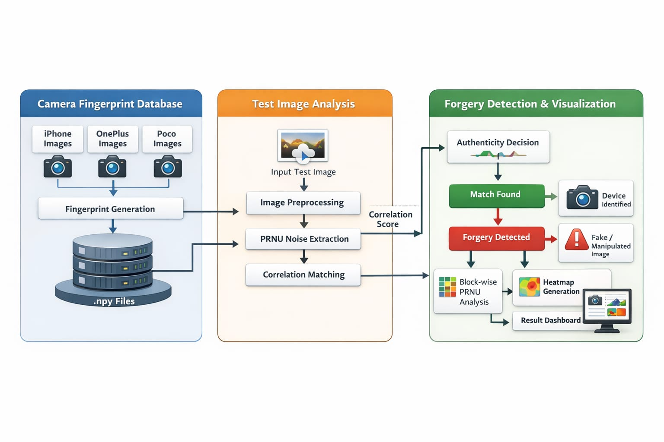

Figure 1: Workflow of the PRNU-based Image Source
Verification and Forgery Detection System

IV. DATA PREPROCESSING AND CLEANING

Initial attempts of image forensics was on identifying inconsistencies that were introduced to the image capture and processing [6]. Photo-Response Non-Uniformity (PRNU), color filter patterns, compression analysis and noise residual extraction were all common techniques to determine the source of an image and identify forgeries [7]. These techniques are based on the assumption that sensor fingerprints are consistent in original images, whereas interference in patterns by manipulated areas is observed in manipulated images. Their performance however degrades in the event that post-processing of images are done using image operations such as JPEG compression, filtering or even resizing of images. Advocates have been weakened by such operations and implementation in sensor noise that render the conventional forensic approaches less effective in the real-life circumstances.

Learning-based image forgery detection techniques have attracted attention with the development of deep learning. There are various sources of digital images, such as mobile devices, social networks, cloud storage providers, video surveillance, and confiscated digital media [6]. These images have diverse backgrounds, and they are taken on diverse camera gadgets under different conditions of taking images.

The PRNU noise residuals that have been extracted are then analyzed to do image source attribution and forgery detection. The identification of whether a picture is created by a certain camera device is made through Correlation analysis and Peak-to-Correlation Energy (PCE) metrics. Block-wise analysis is also used to determine suspicious areas in the image by checking of the localized PRNU inconsistency. The total working workflow provides the opportunity to the investigators to easily check the authenticity of images, assign images to the source devices, and identify potential manipulations with the organization and automation.

The image datasets obtained due to varied sources of images will often contain inconsistencies (unequal resolutions, compression formats (e.g. JPEG, PNG), resizing artifacts and noise distortions as well as post-processing effects). Also, images can undergo manipulations of splicing, copy movements, or enhancement, either deliberately or by borking processes used in social media. Consequently, the raw image data can be said to be noisy, inconsistent or partially degraded, direct forensic analysis cannot be trusted [7].

V. IMAGE SOURCE ATTRIBUTION AND PRNU
ANALYSIS

A fundamental feature of the suggested forensic model is image source attribution, which converts processed image evidence into forensic intelligence. There is some slight manufacturing flaws in every digital camera sensor, which produce a random PRNU pattern [6]. These patterns serve as intrinsic identifiers and this means that they allow association of images to the camera devices that were used to take them.

Here, PRNU fingerprints of a reference are created by utilizing a number of images that were taken with familiar camera gadgets [1]. Given a query image its noise residual extracted is matched against known camera fingerprints at the frequency-domain level with the frequency-domain based correlation tools. The derived values of PCE represent the intensity of relationship between the image and a certain camera equipment. A high value of correlation would mean that the image was generated by the respective device whereas low correlation would imply a mismatch.

The system runs a block-wise PRNU analysis to identify image manipulation, which splits the image into non-overlaps regions and estimates PRNU consistency at local scales. There are those regions that deviate much with the fingerprint of the camera of the world and hence are detected to be suspicious which implies splicing or localized tampering. Such a local analysis not only helps the investigators to spot the forgery, but it also helps them to locate and find the spatial position of the manipulated spots within the image.

Automation of PRNU extraction, correlation and block-wise assessment minimizes human resource and cognitive toxins on investigators. The framework is an overall representation of authenticity of images and consistency of the source, which facilitates the proper and quantitative forensic examination.

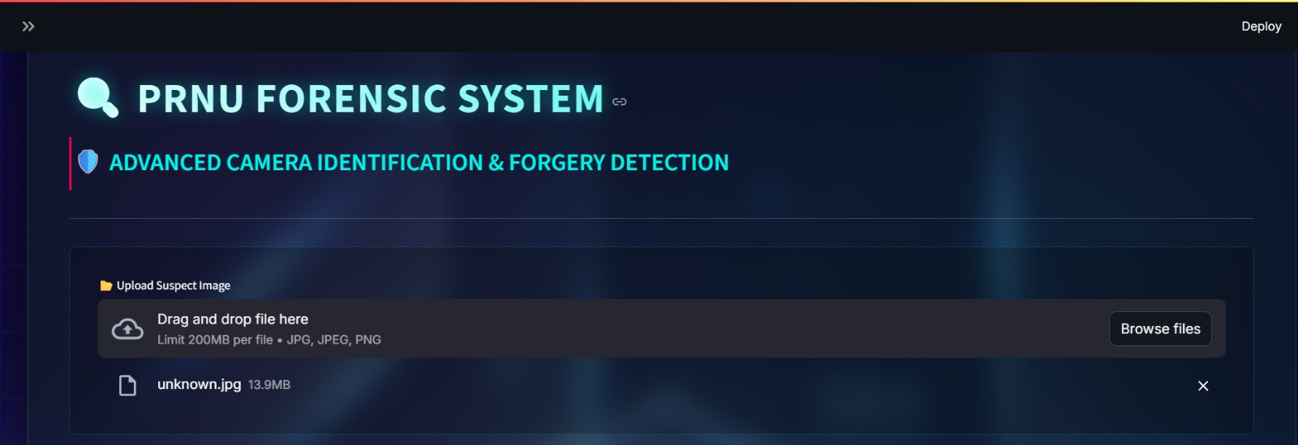

Figure 2: PRNU Based Forensics Dashboard

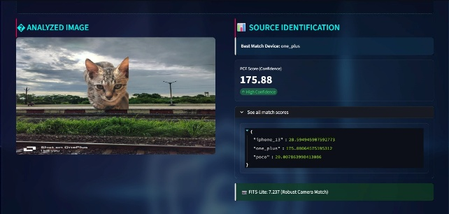

Figure 3: PRNU-based Source Attribution and Local Forgery Localization

- VISUALIZATION FRAMEWORKS

In forensic analysis, visualization is of paramount importance in explaining non-straussackant results of the complex analysis. The suggested framework uses visual tools in framing analytical findings with PRNU heatmaps, correlation plots, and confidence indicators to provide the findings in an intuitive and user-friendly format. These graphic tools will turn the numbers of correlation measures and block wise inconsistency measures into interpreted visual formats.

The heatmaps employ them to indicate suspect areas in an image and therefore, allow investigators to find areas of possible manipulation with ease. The results of camera attribution are summarized with the help of the confidence score and the graphical indicators which help in quick decision making. The interactive dashboards also lower the cognitive load burden because it enables investigators look into forensic outcomes without necessarily analysing the numerical raw results manually.

Visualization systems also enhance the efficiency of investigation since they are able to identify patterns faster and detect anomalies. The system can increase the accuracy and usability of digital image investigations in the field by applying complex PRNU-based forensic information to help the prosecutor access the evidence in a format comprehensible to the standard investigator [7].

- REPORT AND EVIDENCE GENERATION

The process of automated report generation should be regarded as a crucial part of the modern forensic systems, allowing recording and reporting analytical finding in a standard format. The forensic outputs in the proposed structure include camera attribution confidence, PRNU correlation measures and forgery localisation outputs that are automatically assembled into structured reports.

The reports may be created in professional formats i.e. PDF and hence consistency and standardization in the forensic documentation. Automated report creation lowers the amount of manpower required, ensures less human error and also allows that evidence of forensics can be easily produced when required to be taken before a legal or investigation body. Reporting on large scales is useful in a variety of ways to improve productivity and ease large forensic investigation.

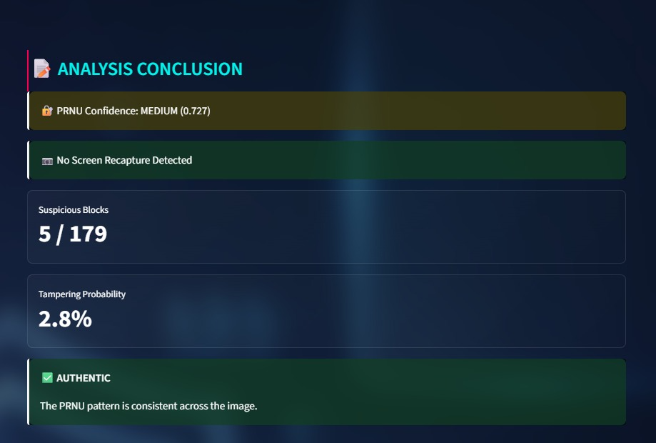

Figure 4: PRNU-based Source Analysis and Local Forgery

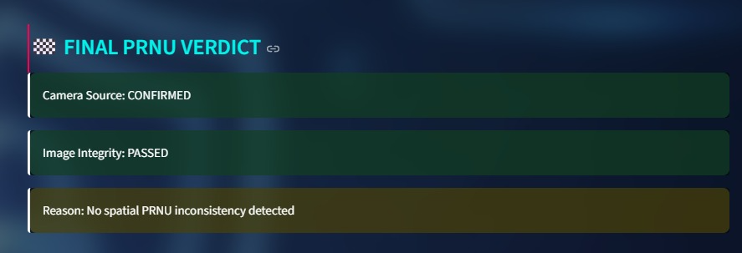

Figure 5: PRNU Final Verdict Analysis

- BACKEND AND DATA MANAGEMENT INTEGRATION

Image data, system interactions and analytical results are taken care of by the backend architecture of the PRNU-based forensic system. Super-lightweight backend systems promote communication between the front-end interface and analytical modules, which allow image upload, PRNU rich extraction, analysis execution, and report generation functions.

Reference camera fingerprints, analysis results and metadata relating to image evidence are stored in scalable data storage mechanisms. The modular backend architecture makes it scalable and flexible so that it can be extended by new forensic functionality or analysis methods. The system is based on efficient data management and inter-component communication that guarantee a stable functioning of the system and provision of action-able forensic insights in time.
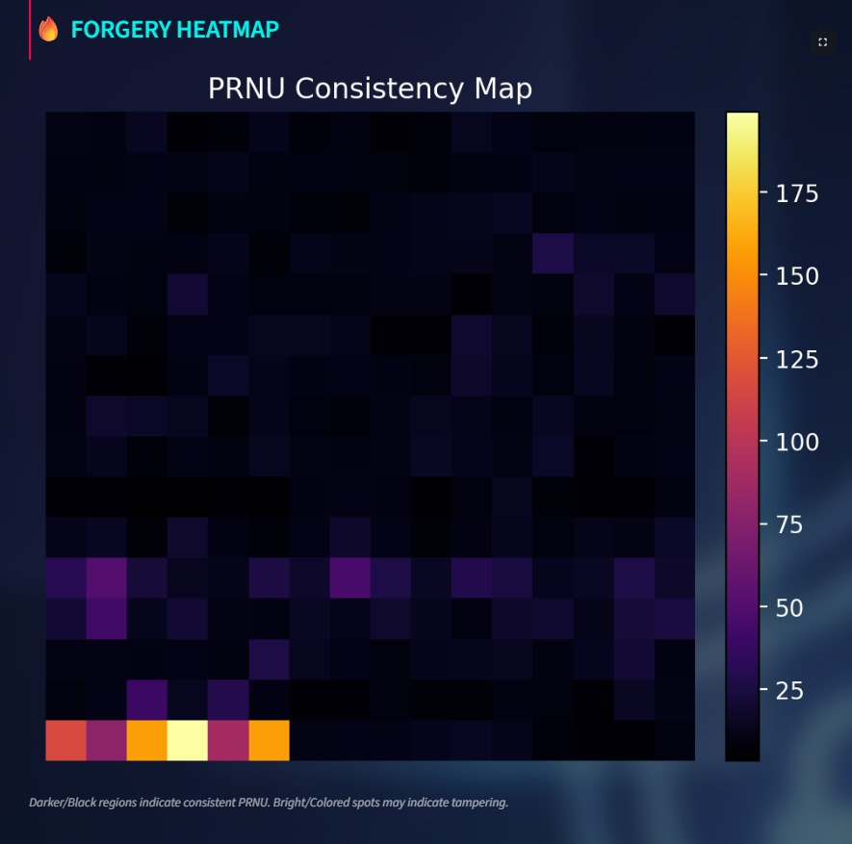

Figure 6: Backend Forgery Heatmap and Forensic Data Storage

IX RESULTS AND DISCUSSION

The experimental analysis verifies that the presented PRNU-based image forgery detection system efficiently detects forged images and locates the altered areas by combining machine learning-based prediction with noise centric forensic examination. The system manages to rank images according to low, medium, and high-risk levels of forgery by combining the likelihood of the forgery at a global scale and PRNU inconsistency at the local scale. Of the tested classifiers, the ensemble-based models performed better than the linear classifiers and have better accuracy, precision, recall, and AUC results. This can be ascribed to the fact that they have the capacity to represent chip and non-linear relationships among PRNU residual characteristics and noise-based forensic cues.

The rule-based forgery risk scoring module was essential in the process of detecting spatially abnormal pattern, including sudden PRNU right-hand correlation, residual energy and boundaries inconsistency between neighbouring regions. These weakened or ignored indicators were usually used to improve the state of the system offering fine-grained localization and forensic interpretability. The rule-based layer was straight forward to provide transparency in a way that the forensic cues were clearly connected to risk decisions so that the analysts could comprehend and confirm the detection results.

A combination of machine learning based forgery probability scores and rule based residual risk assessments (weighted) produced an effective and holistic approach to assess image authenticity. This combination made false positives due to isolated noise artifacts to be minimized and genuinely manipulated regions to be highlighted accordingly. In general, the findings prove that the suggested hybrid framework is strong, understandable, and efficient in detecting image forgeries in the conditions of post-processing, and it can therefore be applied to the real-life processes of digital forensics.

X.CONCLUSION

The study proposed a unified PRNU-based image forgery detection system as a integration of both machine-learning and rule based forensic methods to provide strong and explainable image forgery detection. Through the use of ensemble learning models and analysis of intrinsic sensor noises, the suggested system presents a more balanced viewing of the authenticity of images without compromising the system in the presence of post processing activities like compression and filtering. According to experimental findings the hybrid method provides good detection accuracy and viable localisation of forged regions even in a tricky situation.

The combination between predictive learning and interpretable rule-based scoring allows proactive and reliable decisions to be reached by forensic investigations without false detections. Further, this modular and layered system architecture is scalable and adaptable to be implemented in a realistic application of digital forensic investigations. In general, the intentioned framework can contribute to a higher level of trust, reliability, and security in digital media analysis because the proposed framework may be a practical and efficient solution to modern image forensics.

REFERENCE

[1] Liu Liu, Xinwen Fu, Xiaodong Chen, Jianpeng Wang, Zhongjie Ba. “ACL: Account Linking in Online Social Networks With Robust Camera Fingerprint Matching” IEEE TRANSACTIONS ON DEPENDABLE AND SECURE COMPUTING, JUNE 2025.

[2] Yuan Rao, Jiangqun Ni, Jiwu Huang.,”Towards JPEGResistant Image Forgery Detection and Localization Via Self-Supervised Domain Adaptation” IEEE TRANSACTIONS ON PATTERN ANALYSIS AND MACHINE INTELLIGENCE, MAY 2025.

[3] Yu Tian, Kunbo Zhang, Yalin Huang, Leyuan Wang. “Cross-Optical Property Image Translation for Face Anti- Spoofing: From Visible to Polarization.” IEEE TRANSACTIONS ON INFORMATION FORENSICS AND SECURITY, 2025.

[4] Tong Qiao , Hang Shao, Shichuang Xie, Ran Shi,. “Unsupervised Generative Fake Image Detector.”, IEEE TRANSACTIONS ON CIRCUITS AND SYSTEMS FOR VIDEO TECHNOLOGY, SEPTEMBER 2024.

[5] Dengyong Zhang, Jiahao Chen, Xin Liao.,” Face Forgery Detection via Multi-Feature Fusion and Local Enhancement”, IEEE TRANSACTIONS ON CIRCUITS AND SYSTEMS FOR VIDEO TECHNOLOGY , SEPTEMBER 2024.

[6] Andrea Montibellerd Fernando Pérez-González. “An Adaptive Method for Camera Attribution Under Complex Radial Distortion Corrections .” IEEE TRANSACTIONS ON INFORMATION
FORENSICS AND SECURITY, 2025.

[7] Peiyu Zhuang, Haodong Li, Rui Yang, and Jiwu Huang.,” ReLoc: A Restoration-Assisted Framework for Robust Image Tampering Localization.” IEEE TRANSACTIONS ON INFORMATION FORENSICS AND SECURITY, 2023.

[8] Li Zhang, Tong Qiao, Ming Xu, Ning Zheng , Shichuang Xie.“Unsupervised Learning-Based Framework for Deep fake Video Detection.” IEEE TRANSACTIONS ON MULTIMEDIA, 2023.

[9] Jia xin Chen , Xin Liao , Wei Wang , Zhen xing
Qian. ,. “ “SNIS : A Signal Noise Separation-Based Network for Post - Processed Image Forgery Detection.”, IEEE TRANSACTIONS ON CIRCUITS AND SYSTEMS FOR VIDEO TECHNOLOGY, FEBRUARY 2023.

[10] Cong Yang, Zhenyu Yang, Yan Ke, Tao Chen, Marcin Grzegorzek, and John SeeDoing More With Moiré Pattern Detection in Digital Photos.”, IEEE TRANSACTIONS ON IMAGE PROCESSING, 2023.

